
Trash and litter prevention media kit
How litter affects water quality and how residents can help
This media kit is designed to support public education around how trash and litter impact local water quality. It can be shared throughout WMWA territory and beyond. All content is editable so organizations can tailor the messaging to their community. This kit includes a sample newsletter article, social media posts, and images to share alongside postings.
Resources to promote Litter Prevention and Water Quality
Ways to educate the public:
- Use the sample newsletter article to share on your organization’s website or in your newsletters. These are editable so you can customize the length or message.
- Use the sample social media posts to share through your social media channels. These are editable so you can customize the message and website.
- Follow and reshare messages posted on the Hennepin County Environment and Energy social media channels: Hennepin Environment on Facebook, Hennepin Environment on Instagram, and @hennepinenviro on X.
Contact
For more information, contact:
Grace Barcelow, Conservation Specialist, grace.barcelow@hennepin.us.

Sample newsletter article – How trash impacts water quality

Small litter, big impact: how trash harms our lakes, rivers, and streams
When people think about threats to clean water, they often imagine industrial pollution or chemical spills. In reality, one of the most widespread and easily preventable sources of water pollution begins right at home with ordinary litter.
Trash on streets, sidewalks, and parking lots doesn’t stay put. When it rains, stormwater carries litter directly into storm drains and from there, straight into local lakes, rivers, and streams without any treatment. Unlike household wastewater, stormwater is not cleaned or filtered.
Common litter items like plastic wrappers, cigarette butts, food containers, and microplastics break down slowly and release harmful chemicals into the water. These pollutants:
- Harm fish, birds, and aquatic life
- Degrade habitat and water clarity
- Introduce toxins into the food chain
- Reduce the quality of drinking water sources
- Increase cleanup costs for cities and watershed districts
Even organic litter like food scraps or yard waste can cause problems. As they decompose, they release excess nutrients that fuel algae blooms and reduce oxygen levels needed by aquatic life.
What residents can do:
Protecting water quality starts with simple, everyday actions:
- Secure your trash. Keep lids closed and bins upright.
- Pick up litter when you see it in your neighborhood, parks, or sidewalks.
- Host a litter clean up! Make sure to properly dispose of what you find. Learn more in the waste sort guide for litter clean ups (PDF).
- Reduce single-use plastics by choosing reusable bags, bottles, and containers.
- Dispose of cigarette butts properly. They are the most common litter item found in waterways.
- Join local cleanup events or organize your own.
Small actions add up. When communities work together to reduce litter, the impact on water quality is immediate and measurable.
For questions or ways to get involved, contact Grace at grace.barcelow@hennepin.us.
Social media posts

Suggested hashtags: #CleanWater #StopLitter #ProtectOurLakes #WaterQuality #Stormwater #KeepItClean
To use images and graphics: right click on image and select Save as Picture

Spring litter clean-up
Facebook: Litter on our streets doesn’t stay on our streets. It washes into storm drains and flows directly into our lakes, rivers, and streams without being treated. This spring, help protect water quality by picking up trash in your neighborhood, securing your garbage bins, and reducing single-use plastics. Small actions make a big difference for clean water. #CleanWater #StopLitter
Instagram: Litter travels. When it rains, trash on sidewalks and streets washes into storm drains and straight into our lakes and rivers. Help keep our waters clean by picking up litter, securing trash bins, and choosing reusable items. Every piece of trash removed protects our waterways. #CleanWater #StopLitter
X: Litter on streets washes into storm drains and flows directly into our lakes and rivers. Help protect water quality by picking up trash and reducing single‑use plastics. #CleanWater #StopLitter
Images:
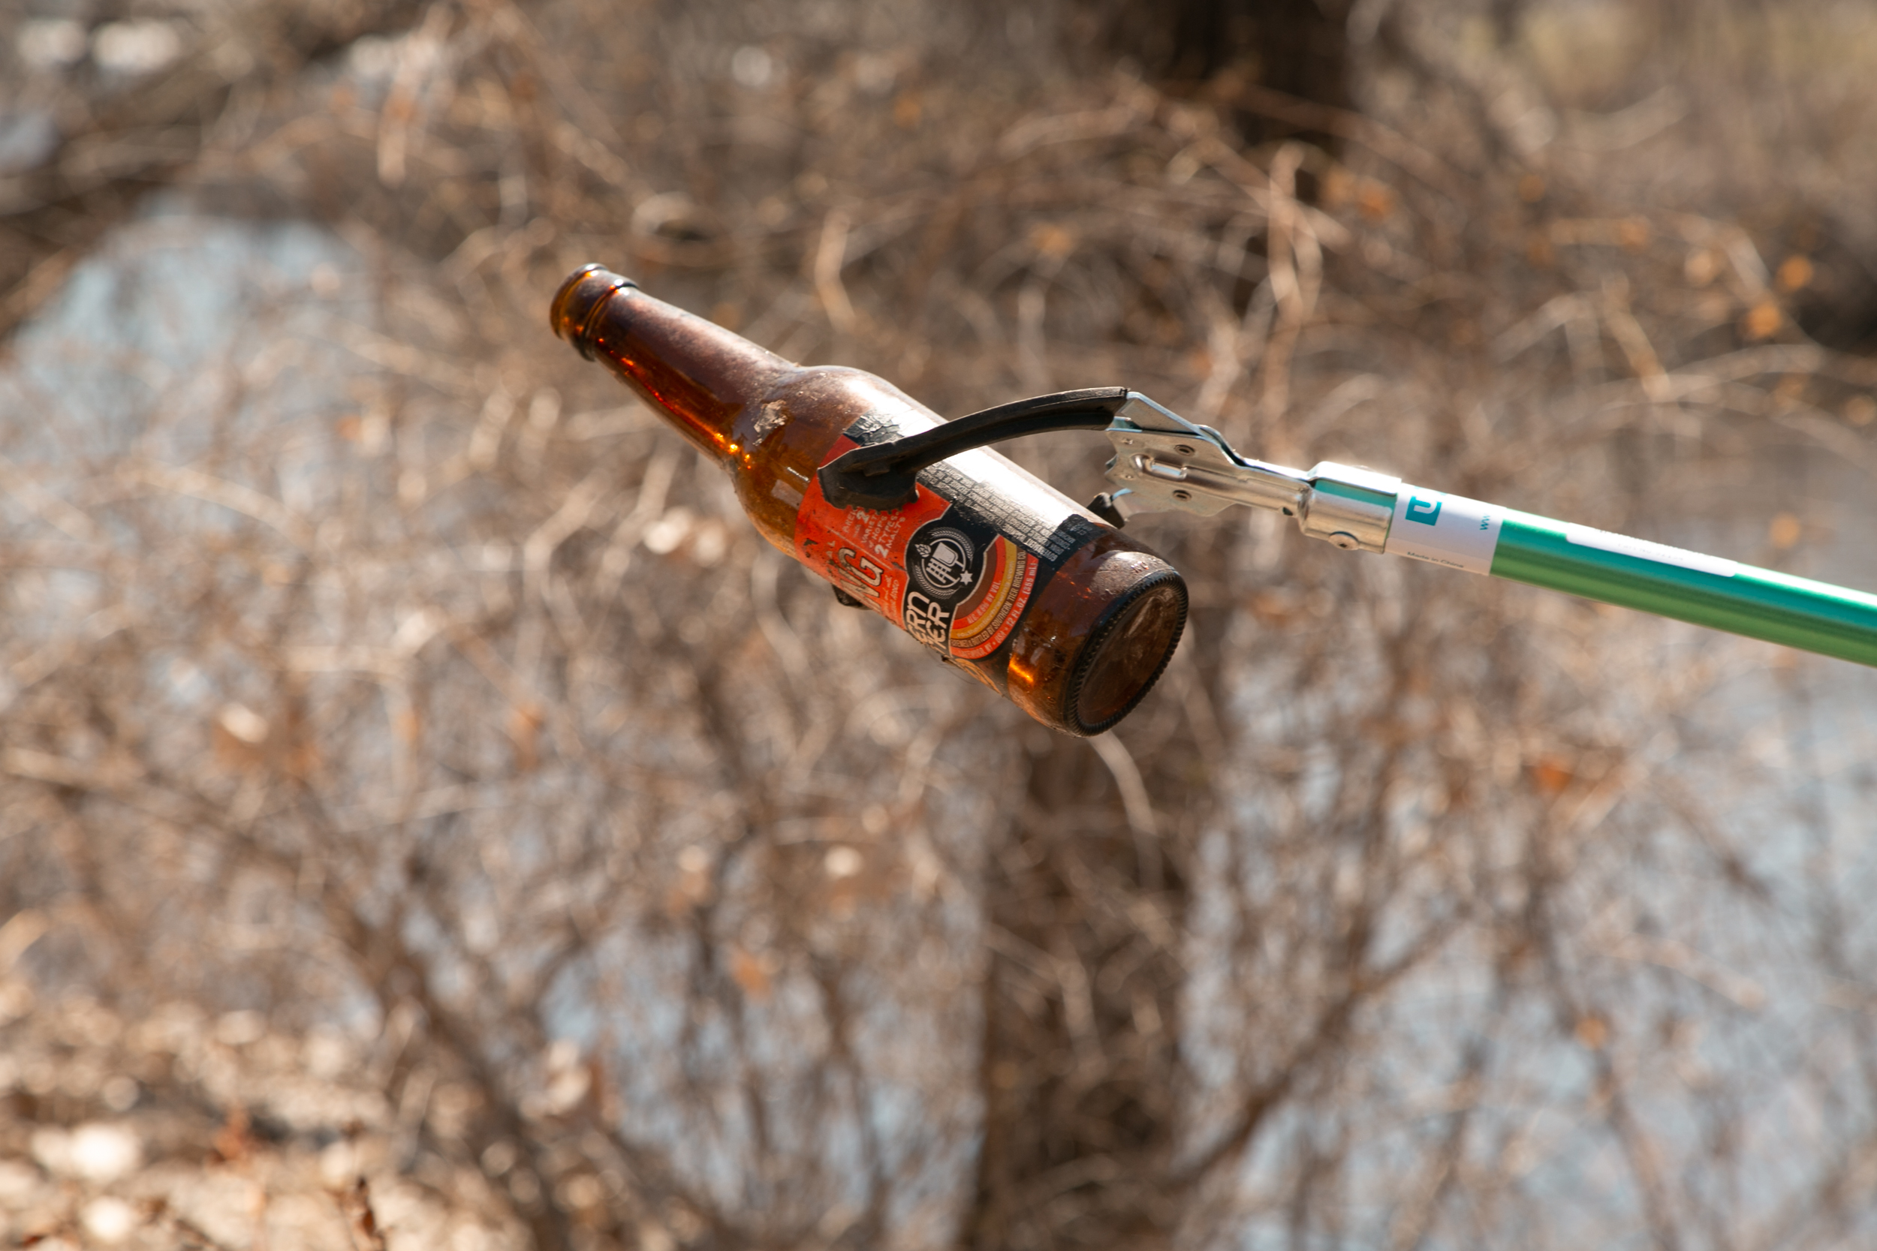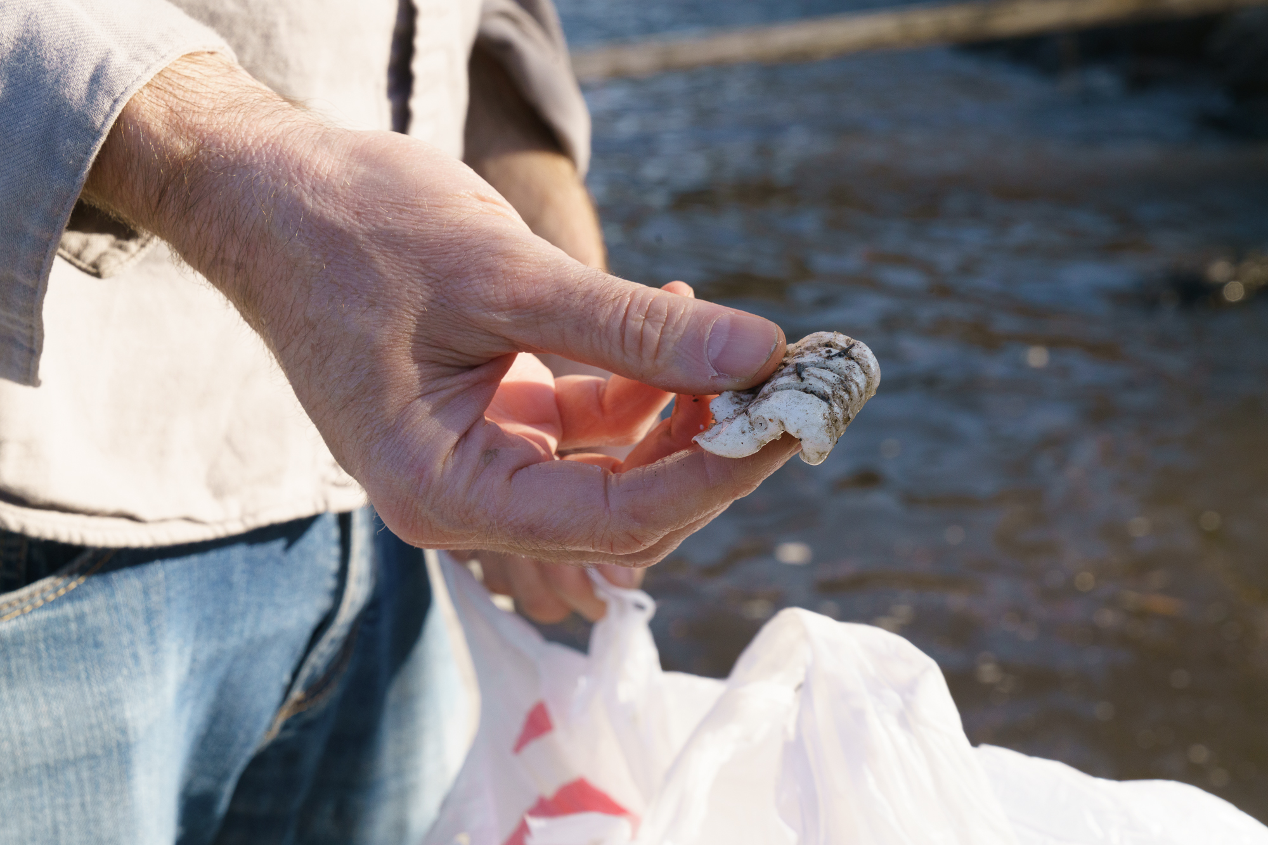Clean Water MN Photos

